Section 1: Case Summary

Scenario Title: | Nightmares Case 1: Bradycardia
Keywords: | Syncope, third-degree heart block, bradycardia
Brief Description of Case: | This is a case of an elderly patient with syncope. He is found to be in third degree heart block. The team is expected to perform an initial assessment and obtain an ECG. Upon recognizing the heart block, they should ensure iv access and place pacer pads while calling for help.

Goals and Objectives
Educational Goal: | - To develop an approach to the patient with syncope
Objectives:  (Medical and CRM) | - To prioritize initial investigations and therapies  - To communicate a clinical scenario in a concise manner to the attending ER physician
EPAs Assessed: | To recognize an acutely unwell patient, call for appropriate help, and initiate a basic assessment and management plan.

Learners, Setting and Personnel
Target Learners: | Medical Students | Junior Residents | Senior Residents
 | Staff Physicians | Inter-professional | Other
Location: | Sim Lab | In Situ | Other
Recommended Number of Facilitators: | Instructors: 1-2
 | Confederates: 1
 | Sim Techs: 1

Scenario Development
Date of Development: | 2014
Scenario Developer(s): | Dr. Tim Chaplin
Affiliations/Institutions(s): | Queen’s University
Contact E-mail: | Chaplintim2@gmail.com
Last Revision Date: | October 2019
Revised By: | Dr. Kyla Caners
Version Number: | 2

Section 2A: Initial Patient Information

- Patient Chart
Patient Name: Robert White |  |  | Age: 82yo |  |  | Gender: Male |  | Weight: 90kg
Presenting complaint: Fall
Temp: 37 | HR: 27 | BP: 80/50 |  |  | RR: 18 |  | O₂Sat: 99 |  | FiO₂: room air
Triage note: Mr. White “fainted” while returning from the bathroom at home. He was found to be slightly more confused by his wife and complained of right elbow pain.

Allergies: NKDA
Past Medical History:  Hypertension  Coronary artery disease (MI in 2011)  Anxiety  Alcoholism  Type-2 diabetes |  |  |  | Current Medications:  Ramipril 10mg PO daily  Metoprolol 100mg PO BID  Metformin 1000mg PO BID  Clonazepam 0.5mg PO TID  ASA 81mg OD,  Insulin humulin 30U qAM and 10U qhs,  Septra 160mg PO BID.

Section 2B: Extra Patient Information

A. Further History
The patient (manikin’s voice): Your head feels a bit “cloudy” and you have elbow pain – you attribute this to the spine board. Otherwise unremarkable review of systems. You do not recall “passing out” at home.

The patient’s RN (confederate): If asked, can inform the learner that the patient’s wife described hearing a “thump” at home and then finding the patient on the floor. There were no signs/symptoms of a seizure.

B. Physical Exam
Other than bradycardia, there are no other significant findings
No significant injuries (no signs of head trauma).

Section 3: Technical Requirements/Room Vision

A. Patient
Mannequin (specify type and whether infant/child/adult). Adult, casual clothes, on a board and collar
Standardized Patient
Task Trainer
Hybrid
B. Special Equipment Required
Cardiac monitors with pacing capability

C. Required Medications
Atropine, epinephrine infusion

D. Moulage
Elderly male in casual clothes on a backboard/C-spine collar.

E. Monitors at Case Onset
Patient on monitor with vitals displayed
Patient not yet on monitor
F. Patient Reactions and Exam
Comfortable, a bit confused but pleasant. Can’t recall “passing out at home” and head still feels a bit “cloudy”.

Section 4: Confederates and Standardized Patients

Confederate and Standardized Patient Roles and Scripts
Role | Description of role, expected behavior, and key moments to intervene/prompt learners. Include any script required (including conveying patient information if patient is unable)
Bedside RN | You can assist with the history – unwitnessed collapse at home and ongoing mild confusion. There are no other pertinent findings on exam.

Section 5: Scenario Progression

Scenario States, Modifiers and Triggers
Patient State/Vitals | Patient Status | Learner Actions, Modifiers & Triggers to Move to Next State |  | Facilitator Notes
1. Baseline State  Rhythm: 3rd degree heart block  HR: 28  BP: 80/50  RR: 18  O₂SAT: 99%  T: 37ºC  GCS: 14 | Mild confusion and amnestic to the event. | Expected Learner Actions  Obtain a focused history  Perform a focused examination  Obtain a 12-lead ECG  Obtain IV access  Send labs (including electrolytes, troponin)  Call staff MD for help | Modifiers  Changes to patient condition based on learner action  Triggers  For progression to next state  - ECG completed 2. Worsening Hypotension
2. Worsening Hypotension  HR: 25  BP: 75/45 | Patient complaining of feeling more lightheaded, then is slower to answer questions. | Expected Learner Actions  Initiate a fluid bolus  Place pacing pads on patient and explain the process of transcutaneous pacing (consider analgesia)  Trial atropine 0.5mg iv  Trial epinephrine infusion  Begin transcutaneous pacing | Modifiers  - Atropine no effect  Triggers  - End case PRN with handover to ER physician

Appendix A: Laboratory Results – None Required for Case

CBC  WBC  Hgb  Plt  Lytes  Na  K  Cl  HCO₃  AG  Urea  Cr  Glucose  Extended Lytes  Ca  Mg  PO₄  Albumin  TSH  VBG  pH  pCO₂  pO₂  HCO₃  Lactate | Cardiac/Coags  Trop  D-dimer  INR  aPTT  Biliary  AST  ALT  GGT  ALP  Bili  Lipase  Tox  EtOH  ASA  Tylenol  Dig level  Osmols  Other  B-HCG

Appendix B: ECGs, X-rays, Ultrasounds and Pictures

Paste in any auxiliary files required for running the session. Don’t forget to include their source so you can find them later!

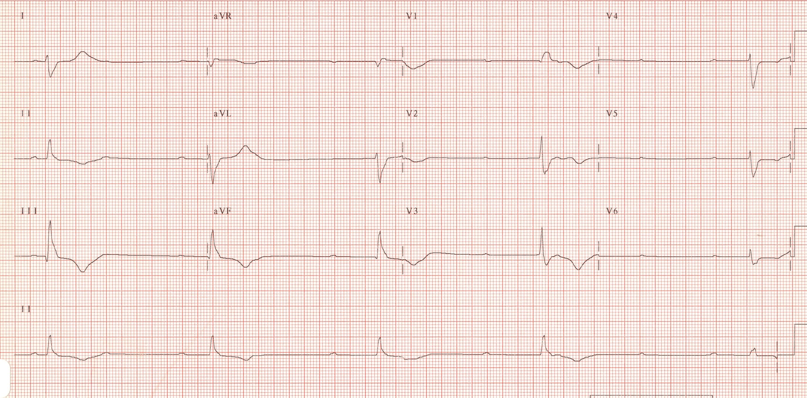

ECG Source: https://www.ecgquest.net/ecg/complete-heart-block-3/

Appendix C: Facilitator Cheat Sheet & Debriefing Tips

Include key errors to watch for and common challenges with the case. List issue expected to be part of the debriefing discussion. Supplemental information regarding any relevant pathophysiology, guidelines, or management information that may be reviewed during debriefing should be provided for facilitators to have as a reference.

- At the junior resident level, the expectation is to perform a focused history and physical examination, recognize profound bradycardia as the most likely cause for the patient’s presentation, and initiate a basic plan. It is not expected that the junior resident independently perform transcutaneous pacing.
- Review the AHA bradycardia algorithm: https://aclsalgorithms.com/wpcontent/uploads/2016/05/Website-Bradycardia-Algorithm-Diagram.pdf

References

1. AHA Guidelines, 2015. https://ahajournals.org/doi/10.1161/CIR.0000000000000261

